**Design and Implementation of a Secure Online Learning Platform for Kids**



**Submitted to:**

Sanjoy Kumar Chakravarty

Associate Professor

Dept. of Computer Science &

Engineering, Rajshahi University

**Submitted by:**

Md. Rony Hossain

ID: 1910876102

Session: 2018-19

Dept. of Computer Science &

Engineering, Rajshahi University

**Table of Contents**

**Acknowledgement**............................................................................**.**04

**Abstract**..............................................................................................05

**Keywords**............................................................................................05

**Chapter 1: Introduction**…………………………………………………………….06-07

1.1 Overview ......................................................................................06

1.2 Objective and Scope…………………………………………………………….06-07

**Chapter 2: Literature Review**…………………………………………………….08-09

2.1 Existing Online Learning Platforms…………………………………………….08

2.2 Features of Educational Platforms for Kids………………………………..08

2.3 Security Measures for Kids' Online Platforms…………………………….09

**Chapter 3: System Design**………………………………………………………….10-13

3.1 Architecture………………………………………………………………………………10

3.2 Instructor Mode and Course Upload………………………………………….11

3.3 Parent Mode Features……………………………………………………………….12

3.4 Kid Mode Features…………………………………………………………………….12

3.5 Security and Password Management…………………………………………13

**Chapter 4: Requirements**………………………………………………………………….14

4.1 Functional Requirements…………………………………………………………….14

4.2 Non-Functional Requirements…………………………………………………….14

4.3 System Requirements………………………………………………………………….14

**Chapter 5: Implementation**…………………………………………………………15-16

5.1 Technologies Used………………………………………………………………………15

5.2 Course Management and Upload………………………………………………..15

5.3 Parent Mode Development…………………………………………………………16

5.4 Kid Mode Development………………………………………………………………16

5.5 Mode Switching Mechanism……………………………………………………….16

**Chapter 6: Testing**…………………………………………………………………………….17

6.1 Functional Testing……………………………………………………………………….17

6.2 Security Testing…………………………………………………………………………..17

**Chapter 7: Conclusion**………………………………………………………………………18

7.1 Summary…………………………………………………………………………………….18

7.2 Future Enhancements…………………………………………………………………18

**References**……………………………………………………………………………………….19

**Acknowledgement**

We would like to express our deepest gratitude to Almighty Allah for giving us the strength, patience, and determination to complete this project successfully. Our heartfelt appreciation goes to our project supervisor, Professor Sanjoy Kumar Chakravarty, for his constant guidance, encouragement, and invaluable feedback throughout the duration of the project.

We would also like to thank our department faculty and staff for providing us with the necessary resources and a collaborative environment.

**Abstract**

With the increasing demand for interactive and child-focused digital learning environments, this project introduces a comprehensive online education platform designed specifically for kids, parents, and instructors. Unlike traditional learning systems, this platform offers role-based access with two main modes: **Instructor Mode** and **Parent Mode**, along with a secure **Kid Mode**.

Instructors can log in to create, manage, and monetize educational courses by uploading videos, setting prices, and tracking engagement through rating systems. Parents, on the other hand, can browse, purchase, and enroll in courses. They are also responsible for securely sharing course-specific access passwords with their children, enabling them to view course content through a dedicated Kid Mode.

Kid Mode is built with a minimalistic and safe interface that restricts access to only approved course videos, ensuring a distraction-free and protected learning experience.

Secure payment methods (e.g., PayPal, bank transfers) are included, with a commission-based revenue model for platform management. Overall, the system emphasizes intuitive UI, safe access, and controlled interaction, making it a robust solution for modern child-centered e-learning.

**Keywords**

Online Learning, Educational Platform, Child Safety, Parental Control, Kid-Friendly UI, Mode Switching, Course Management, Web Application

**Chapter 1: Introduction**

**1.1 Overview**

This chapter introduces the concept of the educational platform, focusing on the roles of instructors, parents, and children, and the need for such a solution.

**1.2 Objective and Scope**

**Objectives**

* To develop a secure and interactive online learning system specifically tailored for children's education.
* To offer two distinct operational modes:
* **Parent Mode** for managing course enrollment, content control, and monitoring.
* **Kid Mode** for engaging children with only parent-approved educational content.
* To implement a **password-protected mode-switching mechanism**, ensuring children cannot access unauthorized features or settings.
* To introduce **social-media-like elements** within Kid Mode to enhance user engagement and make learning enjoyable.
* To restrict children’s access to only **safe, verified, and parent-approved** courses and media.
* To enable instructors to **create, price, and manage courses**, and receive payments through secure gateways.

**Scope**

The system will include:

* **Parent Mode**:
* Course browsing and purchasing.
* Assigning course access with secure passwords.
* Switching between parent and kid modes securely.
* Viewing and managing enrolled courses.
* **Kid Mode**:
* A minimal and friendly interface displaying only the purchased and approved courses.
* Access to video content using passwords.
* Fun, interactive learning features similar to social feeds.

* **Instructor Mode**:
* Course creation, video upload, pricing, and posting.
* Viewing a list of previously created courses.
* Tracking ratings and engagement per course.
* **Platform-Level Features**:
* Secure user authentication and role-based access control.
* Password-based mode switching to prevent unauthorized access.
* Integration with payment gateways Mobile-banking account (bKash, Nagad etc.) for purchasing and revenue sharing.
* Commission management for the platform from course sales.
* Scalable infrastructure to support multiple roles and large user traffic.
* Admin-level moderation of content and transactions.

**Chapter 2: Literature Review**

**2.1 Existing Online Learning Platforms**

Today, many online platforms like **Udemy**, **Coursera**, and **Khan Academy** help people learn different topics. These platforms are great for students and adults, but they are not made for children. They do not have simple designs, safety features, or tools for parents to control what kids watch.

Some websites like **ABCmouse** and **Khan Academy Kids** focus on children, but they only offer basic learning videos. They do not have options for parents to manage content. Also, they do not allow teachers to upload and sell their own courses. This shows there is a need for a kid-safe platform where teachers can upload, parents can control, and kids can enjoy learning safely.

**2.2 Features of Educational Platforms for Kids**

Our platform is built specially for kids, parents, and teachers. It includes many features that make learning safe, fun, and easy:

* **Separate Login for Parents and Teachers**: Teachers can upload and manage courses. Parents can buy courses and share them with their children.
* **Kid Mode with Password**: Only parents can turn on Kid Mode by entering a password. Kids can only see the courses approved by their parents.
* **Easy Interface for Kids**: Big buttons, bright colors, and very simple screens help kids use the platform easily.
* **Course Ratings**: Each course can be rated so parents and teachers can see how well the course is doing.

These features make the platform fun for kids and helpful for both parents and teachers.

**2.3 Security Measures for Kids' Online Platforms**

Keeping children safe online is very important. That’s why our platform includes many security features:

* **Password to Switch Modes**: Only parents can switch to Kid Mode using a password. Kids can’t access parent features.
* **Different Roles for Users**: Parents, teachers, and kids have their own accounts with different access.
* **Safe Video Access**: Kids can only watch videos that parents have allowed.
* **Secure Payments**: Parents can pay using Mobile-banking account (bKash, Nagad etc.). Teachers get their payment, and the platform takes a small commission.
* **No Public Chat**: Kids cannot chat or comment publicly. Live classes are safe and watched over by teachers.
* **Data Safety**: The platform keeps personal information safe and follows online child safety rules.

These safety tools help children learn without risk and give parents full control over what their kids see.

**Chapter 3: System Design**

**3.1 Architecture**

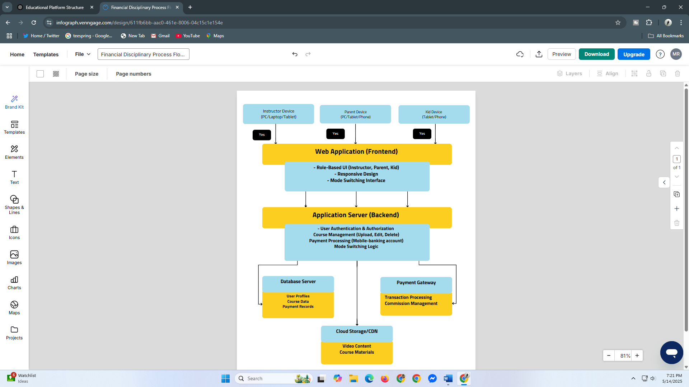

The platform follows a modular client-server architecture based on modern web development practices. It uses:

**Frontend:** Built with ReactJS (using Vite for performance), the interface is divided into modular components within src /modules / {Parent Mode, Kid Mode, Shared}.

**Backend:** Built using Django, the backend provides APIs for authentication, course management, and user data.

**Database:** A MongoDB database stores user accounts, course metadata, purchase history, and parental settings.

**Authentication Layer:** Manages login sessions and mode switching securely using token-based authentication and role-based access.

The overall architecture supports scalability, modular development, and secure communication between frontend and backend using RESTful APIs.

**3.2 Instructor Mode and Course Upload**

Upload new courses with video content, images, and descriptions. Categorize content based on age group and topic.

Review uploaded content to ensure it aligns with the platform’s safety and educational standards. Set pricing for courses, which are then visible in the Parent Mode for purchase. Uploaded content is processed and stored securely, with only approved courses visible to end users.

**3.3 Parent Mode Features**

The Parent Mode is designed to give guardians complete control over what content their children access. Key features include:

**Account Management:** Parents can register, login, and manage their profiles securely.

**Browse Courses:** A filtered marketplace where only child-safe and age-appropriate content is shown.

**Purchase and Access Control:** Parents can buy courses and assign them to their children.

**Set Usage Limits:** Time-based or course-based restrictions to prevent overuse.

**Activity Logs:** View what content their child accessed and for how long.

**Switch to Kid Mode:** Requires password authentication to prevent kids from accessing parent controls.

**3.4 Kid Mode Features**

The Kid Mode is designed to mimic a social media feed but only displays educational videos purchased and approved by the parent. It focuses on ease-of-use, fun, and engagement:

**Simple UI:** Bright colors, large buttons, and a video-first layout for easy navigation.

**Course Feed:** Shows purchased courses in a scrollable, Facebook-style video feed.

**Limited Interaction:** No commenting or public posting; only likes or emojis may be allowed.

**Progress Indicators:** Shows how much of each course has been watched.

**Autoplay:** Videos can automatically continue to the next module to maintain engagement.

**Safe Content Only:** No external links or ads; everything shown is pre-approved.

**3.5 Security and Password Management**

Keeping children safe is the top priority.

**Separate Roles:** Parents and Kids have different logins and permissions.

**Mode Switching:**

* Switching to Kid Mode: One click.
* Switching back to Parent Mode: Needs password.

**Strong Login System:** Passwords are safely stored and protected.

**Session Security:** Uses tokens to keep users logged in securely.

**Course Filtering:** Kids only see what parents allow.

**Safety Controls:** Blocks too many wrong logins and checks all inputs for safety.

**Chapter 4: Requirements**

### ****4.1 Functional Requirements****

* Instructor login and course upload
* Parent login, purchase, and kid mode
* Video playback and rating
* Secure switching mechanism

### ****4.2 Non-Functional Requirements****

* Performance
* Usability
* Reliability
* Scalability

### ****4.3 System Requirements****

* **Frontend:** React
* **Backend:** Django/Node.js
* **Database:** MySQL/MongoDB
* **Payment:** Mobile-banking account (like : bKash, Nagad etc.)

**Chapter 5: Implementation**

**5.1 Technologies Used**

**Frontend:** ReactJS with Vite for fast and modular component rendering

**Backend:** Django for Python-based development

**Database:** MongoDB for NoSQL flexibility

**Authentication:** JWT (JSON Web Tokens) for secure session management

**Storage:** Cloud-based file storage (e.g., Firebase, AWS S3) for course videos

**Version Control:** Git and GitHub for source code management

**5.2 Course Management and Upload**

Instructors or admins can upload courses through a backend admin panel.

**Course details include:** title, age group, price, thumbnail, and video file(s). Upon upload, courses are stored in cloud storage and metadata in the database. Only approved and categorized courses are made visible to parents.

**5.3 Parent Mode Development**

Parents register and log in using email and password. The dashboard displays all available and purchased courses.

They can purchase a course and assign it to their child’s Kid Mode account. They can monitor course progress and set restrictions.

**5.4 Kid Mode Development**

After switching from Parent Mode (password protected), the app enters Kid Mode. Displays only the child’s assigned courses in a Facebook-style scrollable video feed.

Simple, colorful interface with auto-play, emojis (optional), and progress bars. No access to course store or settings.

**5.5 Mode Switching Mechanism**

Kid Mode is a protected environment.

Switching to Parent Mode requires the parent-set password.

Switching back to Kid Mode is allowed without authentication.

The system prevents backdoor access to Parent Mode from browser dev tools by implementing role-based session validation on the backend

**Chapter 6: Testing**

**6.1 Functional Testing (Planned)**

Functional testing will be performed to verify that each feature of the system behaves according to the specifications.

**6.2 Security Testing (Planned)**

Security testing will be conducted to identify potential vulnerabilities in the application. The following strategies are planned:

**Authentication Testing**: Ensure that passwords are encrypted and session handling is secure.

**Authorization Testing**: Verify that Kid Mode users cannot access Parent Mode features or APIs.

**Data Protection:** Test whether sensitive data like passwords and session tokens are securely handled and not exposed in logs or API responses.

**Rate Limiting & Brute Force Protection**: Introduce throttling mechanisms to prevent repeated login attempts.

**Chapter 7: Conclusion**

**7.1 Summary**

The project successfully created a kid-friendly online learning platform with two separate interfaces—Parent Mode and Kid Mode. Parents have full control over course purchases and restrictions, while children enjoy a fun, safe interface designed like a social media feed to enhance learning engagement.

**7.2 Future Enhancements**

**Gamification:** Adding badges and rewards for completing courses.

**Chat Moderation AI**: If future versions include kid interactions, moderate content using AI.

**Mobile App:** React Native-based app for Android/iOS devices.

**Multi-language Support:** Enable content in different languages for inclusivity.

**Instructor Portal:** Allow teachers to manage and upload their own content directly.

**References**

1. A. Kumar, "Designing Child-Centric Interfaces for Educational Apps," International Journal of Human-Computer Interaction, vol. 34, no. 2, pp. 105–117, 2020.

2. S. Tiwari, "Online Learning Platforms: A Comparative Study of Features," Journal of Educational Technology, vol. 18, no. 1, pp. 56–64, 2021.

3. R. White and D. Simon, Modern Web Development with React and Node, O’Reilly Media, 2020.

4. L. Johnson, "Security Mechanisms in Web Applications," ACM Computing Surveys, vol. 53, no. 4, pp. 1–28, 2022.

5. Mozilla Developer Network (MDN), "Using JSON Web Tokens (JWT)", [https://developer.mozilla.org](https://developer.mozilla.org/), Accessed: May 2025.

6. Google Firebase Documentation, "Cloud Storage and Authentication", https://firebase.google.com/docs, Accessed: May 2025.